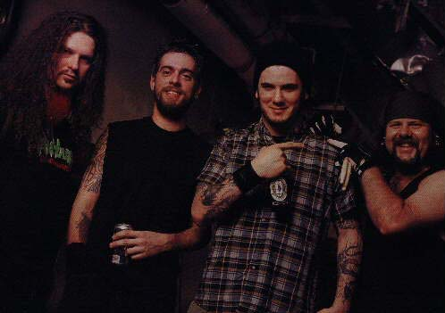

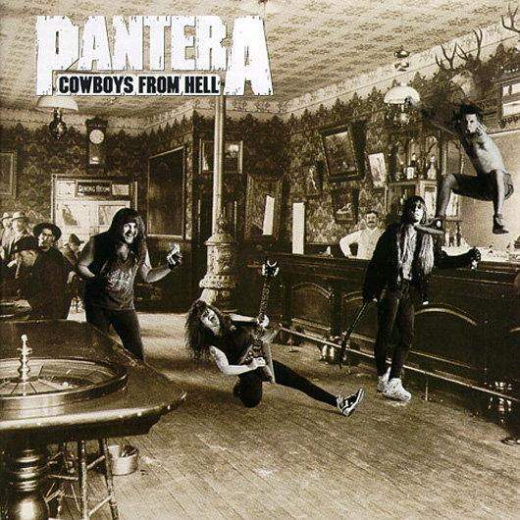

|  |  |
| --- | --- |
| [1.Cowboys From Hell](http://mojim.com/cn101997x4.htm#1)  [2.Primal Concrete Sledge](http://mojim.com/cn101997x4.htm#2)  [3.Psycho Holiday](http://mojim.com/cn101997x4.htm#3)  [4.Heresy](http://mojim.com/cn101997x4.htm#4)  [5.Cemetary Gates](http://mojim.com/cn101997x4.htm#5)  [6.Domination](http://mojim.com/cn101997x4.htm#6) | [7.Shattered](http://mojim.com/cn101997x4.htm#7)  [8.Clash With Reality](http://mojim.com/cn101997x4.htm#8)  [9.Message In Blood](http://mojim.com/cn101997x4.htm#9)  [10.Medicine Man](http://mojim.com/cn101997x4.htm#10)  [11.The Sleep](http://mojim.com/cn101997x4.htm#11)  [12.The Art Of Shredding](http://mojim.com/cn101997x4.htm#12) |

1.[Cowboys From Hell](http://mojim.com/twy101997x4x1.htm" \o "歌词Cowboys From Hell)

Under the lights where we stand tall  
Nobody touches us at all  
Showdown, shootout, spread fear within, without  
We're gonna take what's ours to have  
Spread the word throughout the land  
They say the bad guys wear black  
We're tagged and can't turn back  
  
You see us comin'  
And you all together run for cover  
We're takin over this town  
  
Here we come reach for your gun  
And you better listen my friend, you see  
It's been slow down below,  
Aimed at you we're the cowboys from hell  
Deed is done again, we've won  
Ain't talking no tall tales friend  
'Cause high noon, your doom  
Comin' for you we're the cowboys from hell  
  
Pillage the village, trash the scene  
转载来自 [※Mojim.com　魔镜歌词网](http://cn.mojim.com)   
But better not take it out on me  
'Cause a ghost town is found  
Where your city used to be  
So out of the darkness and into the light  
Sparks fly everywhere in sight  
From my double barrel, 12 gauge,  
Can't lock me in your cage  
  
You see us comin'  
And you all together run for cover  
We're takin over this town  
  
Here we come reach for your gun  
And you better listen my friend, you see  
It's been slow down below,  
Aimed at you we're the cowboys from hell  
Deed is done again, we've won  
Ain't talking no tall tales friend  
'Cause high noon, your doom  
Comin' for you we're the cowboys from hell  
  
转载来自 [※Mojim.com　魔镜歌词网](http://cn.mojim.com)

2.[Primal Concrete Sledge](http://mojim.com/twy101997x4x2.htm" \o "歌词Primal Concrete Sledge)

There's a double standard for the way we live  
If there's nothing to have, well then there's nothing to save  
I'll break a sweat and I don't regret  
What you'd kill to see brings out the god in me.  
  
Come and be with me  
Live my twisted dream  
Pro devoted sledge  
Time for primal concrete sledge  
  
The man of a thousand retirements  
转载来自 [※Mojim.com　魔镜歌词网](http://cn.mojim.com)   
Will always be the one to tell you when to quit  
I won't take stock in a withered man  
I'm reaching into you, I'll make you understand  
  
Come and be with me  
Live my twisted dream  
Pro devoted sledge  
Time for primal concrete sledge

3.[Psycho Holiday](http://mojim.com/twy101997x4x3.htm" \o "歌词Psycho Holiday)

Empty and sweating  
Head lying in your hands  
Shaking in the corner  
Done too much alcohol  
Gotta get away from it all  
'Cause it feels my blood is freezing  
My self insanity has taken its toll  
Frustration has taken its control  
  
Now I'm far from home  
Spending time alone  
It's time to set my demons free  
Been put to the test  
My mind laid to rest  
I'm on a psycho holiday  
  
Shot down on sight  
You are the target of attention  
One woman here another there  
You can't please all the people all the time  
Can't tell the strangers  
From the friends you know  
Frustration has taken it's control  
  
Now you're far from home  
转载来自 [※Mojim.com　魔镜歌词网](http://cn.mojim.com)   
Spending time alone  
It's time to set your demons free  
Been put through the test  
Your mind laid to rest  
You're on a psycho holiday  
  
I'm strapped in for life  
Is this where I lived  
Or where I died  
You want my money  
You take my space  
My mind is telling me  
To leave this place  
My self insanity has taken its toll  
Frustration has taken its control  
  
Now you're far from home  
Spending time alone  
It's time to set your demons free  
Been put through the test  
Your mind laid to rest  
You're on a psycho holiday

4.[Heresy](http://mojim.com/twy101997x4x4.htm" \o "歌词Heresy)

Here we are  
In a world of corruption  
Human nature is  
Of violent Breed  
Who cares if there;s no tomorrow  
When I die for my future's  
Laid out for me  
Can't you see?  
Rise above the lies  
Morals on a backwards globe  
A sin to you  
For me it's hope.  
  
It's my life and provision  
Black or white  
Some pay to pray  
You question why they  
Act this way  
It's their fucking decision  
  
No more judgement day  
Only tranquility  
Peace signs, protest lines  
Mean nothing to me  
  
Honesty born in me  
转载来自 [※Mojim.com　魔镜歌词网](http://cn.mojim.com)   
Heresy  
  
I know what's right or wrong  
And my belief is stronger  
Than your advice  
People, they go to war  
Because religion gives them  
Reason to fight  
Sacrifice, die for pride  
A group that caters  
No one's fees  
Or synthetic deities  
Is where I belong  
My stand is the human race  
Without a label or a face  
So they can lick my sack  
  
No more judgement day  
Only tranquility  
Peace signs, protest lines  
Mean nothing to me  
  
Honesty born in me  
Heresy

5.[Cemetary Gates](http://mojim.com/twy101997x4x5.htm" \o "歌词Cemetary Gates)

The reverend he turned to me  
Without a tear in his eyes  
It's nothing new for him to see  
I didn't ask him why  
I will remember  
The love our souls had  
Sworn to make  
Now I watch the falling rain  
All my mind can see  
Now is your (face)  
  
Well I guess  
You took my mouth  
I gave it all away  
Like the birth of a  
New-found joy  
This love would end in rage  
And when she died  
I couldn't cry  
The pride within my soul  
You left me incomplete  
Memories now unfold.  
  
Believe the word  
I will unlock my door  
And pass the  
Cemetery gates  
  
转载来自 [※Mojim.com　魔镜歌词网](http://cn.mojim.com)   
Sometimes when I'm alone  
I wonder aloud  
If you're watching over me  
Some place far abound  
I must reverse my life  
I can't live in the past  
Then set my soul free  
  
Belong to me at last  
Through all those  
Complex years  
I thought I was alone  
  
I didn't care to look around  
And make this world my own  
And when she died  
I should've cried and spared myself some pain...  
Left me incomplete  
All alone as the memories still remain  
  
The way we were  
The chance to save my soul  
And my concern is now in vain  
Believe the word  
I will unlock my door  
And pass the cemetery gates

6.[Domination](http://mojim.com/twy101997x4x6.htm) ([修改](http://mojim.com/cnthx101997x4x6x1.htm))

Agony is the price  
That you'll pay in the end  
Domination consumes you  
Then calls you a friend  
It's a twisted fall  
Binds are like steel  
And manipulates the will to be  
And it's hard to see  
How soon we forget  
When there's nothing else  
Left to destroy  
It's a useless ploy  
  
Your eyes will see  
The dawn of the day  
And the writing  
On the wall  
Those words that stare  
Into your soul  
And to yourself  
You will befall  
  
It's domination pushed into living hell  
Domination a now blacked heart  
Is reaching out divinity  
Body suspended by chains over razors  
And nails it's a penalty  
Each razor a vice and each nail  
转载来自 [※Mojim.com　魔镜歌词网](http://cn.mojim.com)   
Marks the demise of you life.  
Grim construction grows  
Has life played a trick  
Sealed you in brick by brick  
Till your end forcing you to bend  
  
Your eyes will see  
The dawn of the day  
And the writing  
On the wall  
Those words that stare  
Into your soul  
And to yourself  
You will befall  
  
It's domination pushed into living hell  
Domination a now blacked heart  
Is reaching out divinity  
Body suspended by chains over razors  
And nails it's a penalty  
Each razor a vice and each nail  
Marks the demise of you life.  
Grim construction grows  
Has life played a trick  
Sealed you in brick by brick  
Till your end forcing you to bend

7.[Shattered](http://mojim.com/twy101997x4x7.htm" \o "歌词Shattered)

It's storming broken glass, corpses left in piles  
Ungracious bludgeonmnet that breaks the earth for miles  
Nothing can stop it, the day has come, from below it's catastrophic  
  
Freezing, there's no healing families are dying  
  
This world is shattered... all shattered  
  
Life crushing turbulence, this wrath can't be denied  
Wishing you could help your friends, standing where they died  
Echoes haunting, a hollow planet, lacerations, dissected nation  
  
Freezing, there's no healing families are dying  
  
This world is shattered... all shattered

8.[Clash With Reality](http://mojim.com/twy101997x4x8.htm" \o "歌词Clash With Reality)

Sometimes I know  
I feel untouchable  
Drowning in life  
Caught up in the accessible  
Back down the ground  
I hear the sound  
there's no escape  
The concrete cloud  
Spilling on me  
Drenching me with  
Laymen's sins  
I hear the sirens  
From the back of me  
I'm crashing face first  
Into the glass eye  
  
Clash with reality  
It rears it's ugly head  
Clash with reality  
The indescribable  
Let the dogs lie  
Where we sleep  
Irrelevant theme  
  
转载来自 [※Mojim.com　魔镜歌词网](http://cn.mojim.com)   
A situation and there's  
Nothing but right  
In kicks the door  
Nobody moves  
'Cause in walks the problem  
Dictates your fate  
Evicts, convicts  
Who'll sign the write of life?  
This now becomes  
Their morbid game  
Who's piss poor excuse  
Is this for a world?  
It swells my hatred  
Day by day  
  
Clash with reality  
It rears it's ugly head  
Clash with reality  
The indescribable  
Let the dogs lie  
Where we sleep  
Irrelevant theme

9.[Message In Blood](http://mojim.com/twy101997x4x9.htm) ([修改](http://mojim.com/cnthx101997x4x9x1.htm))

There's a place that I keep deep inside me  
It can trigger my mind  
All along I knew it has been with me  
Since I was just a child  
  
I just summon power within my soul  
It has given me life, beyond life I take  
Blame for my murderous problem my signature  
Always reminds  
  
It's a message in blood  
It's your cryptic warning  
Within the message in blood  
Marks the years of pain,  
And your godforsaken ending to life  
  
转载来自 [※Mojim.com　魔镜歌词网](http://cn.mojim.com)   
I'm provoked into sick confrontations, brutal  
Time after time, bed of nails, suffocation,  
life's ending, slay in different designs  
One mans misery is another mans mystery  
No one cares to understand my  
Demented means  
Sticks and stones can break all your  
brittle bones, epitaph written at your feet  
  
It's a message in blood  
It's your cryptic warning  
Within the message in blood  
Marks the years of pain,  
And your godforsaken ending to life

10.[Medicine Man](http://mojim.com/twy101997x4x10.htm) ([修改](http://mojim.com/cnthx101997x4x10x1.htm))

Many distant miles away  
Past the shores of ever dark  
There stays a magic man  
Who bears an evil mark  
He helps all concerned  
Those who come again return  
Injecting lies while fires burn  
The devil's heart  
With angel's words  
Have you wondered  
What heaven's like?  
He can show you in one night  
Overwhelming with euphoric lift  
To lure you to steal your gift  
  
Intoxication  
Seeping down to the bone  
And there's no question  
Where you have to go  
  
Understand just take his hand  
He's the medicine man  
  
转载来自 [※Mojim.com　魔镜歌词网](http://cn.mojim.com)   
Once proud and fearless men  
With desire in their eyes  
Lost strong and fruitful lives  
To self-indulgent ties  
Their souls were dipped in venom  
And put into a box  
Then placed upon a crowded shelf  
Where countless souls now rot  
Have you ever wondered what hell's like?  
He can take you there  
Just one taste and you'll be back  
And by the high you'll swear  
  
Intoxication  
Seeping down to the bone  
And there's no question  
Where you have to go  
  
Understand just take his hand  
He's the medicine man  
  
转载来自 [※Mojim.com　魔镜歌词网](http://cn.mojim.com)

11.[The Sleep](http://mojim.com/twy101997x4x11.htm) ([修改](http://mojim.com/cnthx101997x4x11x1.htm))

Understanding what has  
Happened before us  
We are confined to a  
Darkened hidden tomb  
The conquering of our world  
As we knew it  
Rise above this pit  
Of sorrow and pain  
Among the few  
We are the avant leaders  
We've got to live  
Through this trouble and decay  
  
This question haunts my mind  
Will we survive this night?  
We're harboring the meek  
Will we survive the sleep?  
转载来自 [※Mojim.com　魔镜歌词网](http://cn.mojim.com)   
  
Unsure and scared  
We are planning our reprise  
Revolves around this world  
We don't know anymore  
The odds against us  
Yet we're stronger and prevailing  
Learn from mistakes  
Counting souls for sale  
  
This question haunts my mind  
Will we survive this night?  
We're harboring the meek  
Will we survive the sleep?

12.[The Art Of Shredding](http://mojim.com/twy101997x4x12.htm" \o "歌词The Art Of Shredding)

Unity is a rare thing  
Blind eyes of society bring  
The category of minority  
Now what are we supposed to be?  
Born free to be  
Powerless to change the world  
With our lives in the hands of madmen  
  
Now in times when society needs us  
This is where the sin begins  
转载来自 [※Mojim.com　魔镜歌词网](http://cn.mojim.com)   
We're aware they're going to free us  
Rage from our hearts within  
Born of this world  
Which is a living hell  
But we'll be closer to heaven  
  
So now, this is the art  
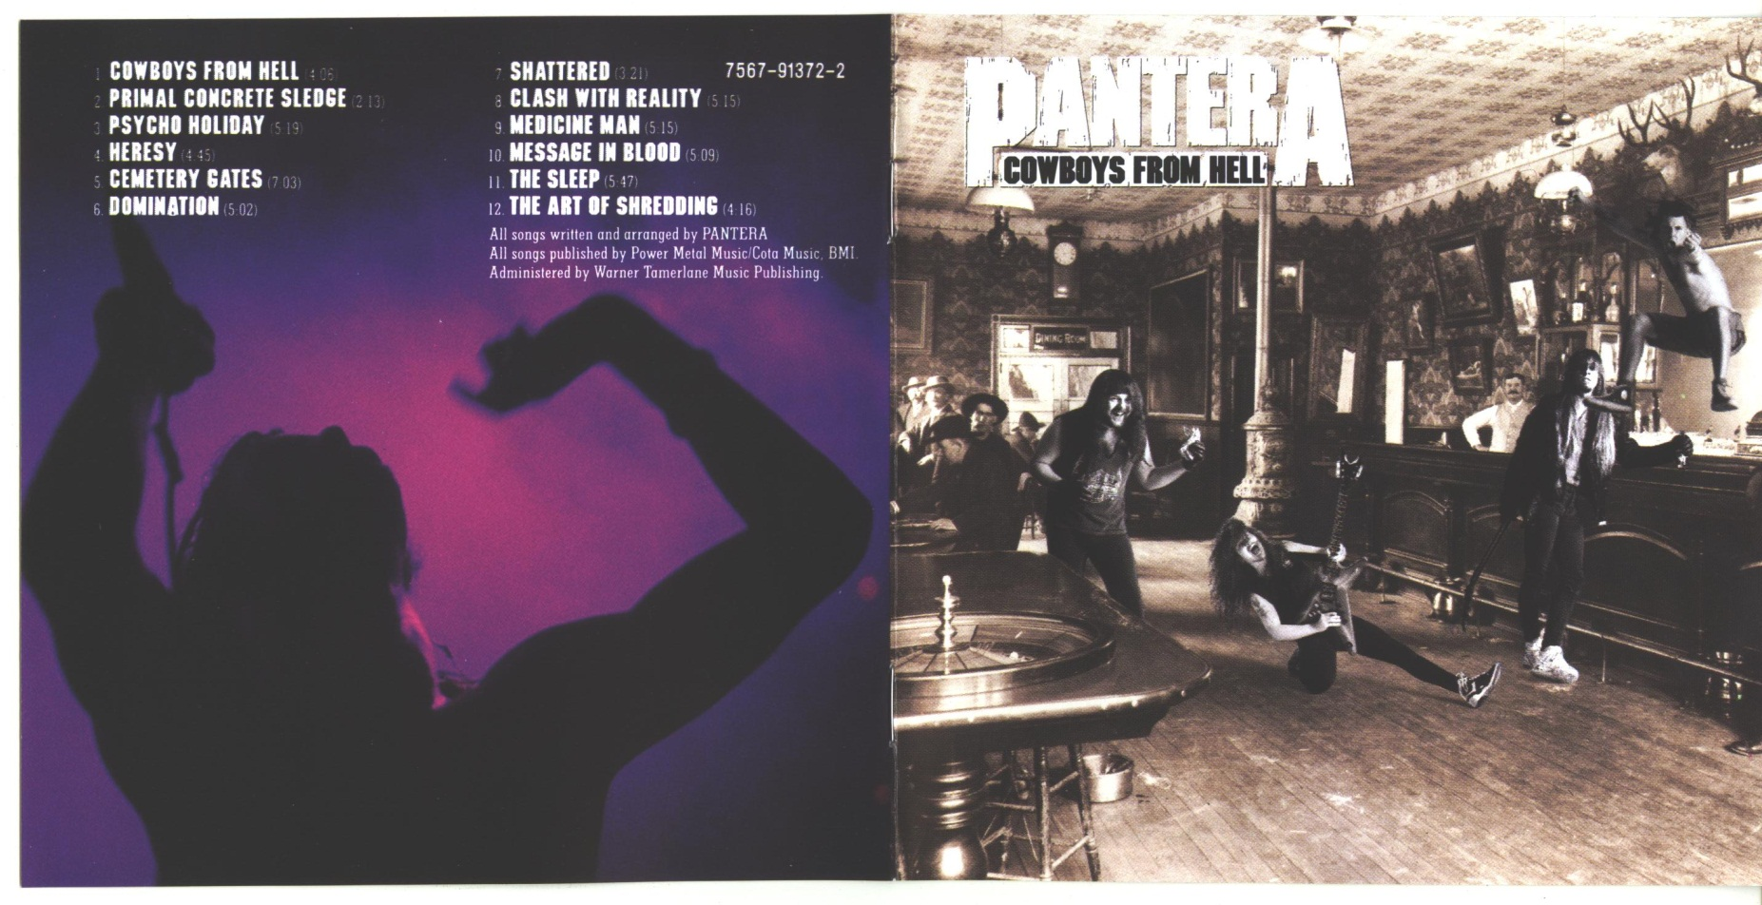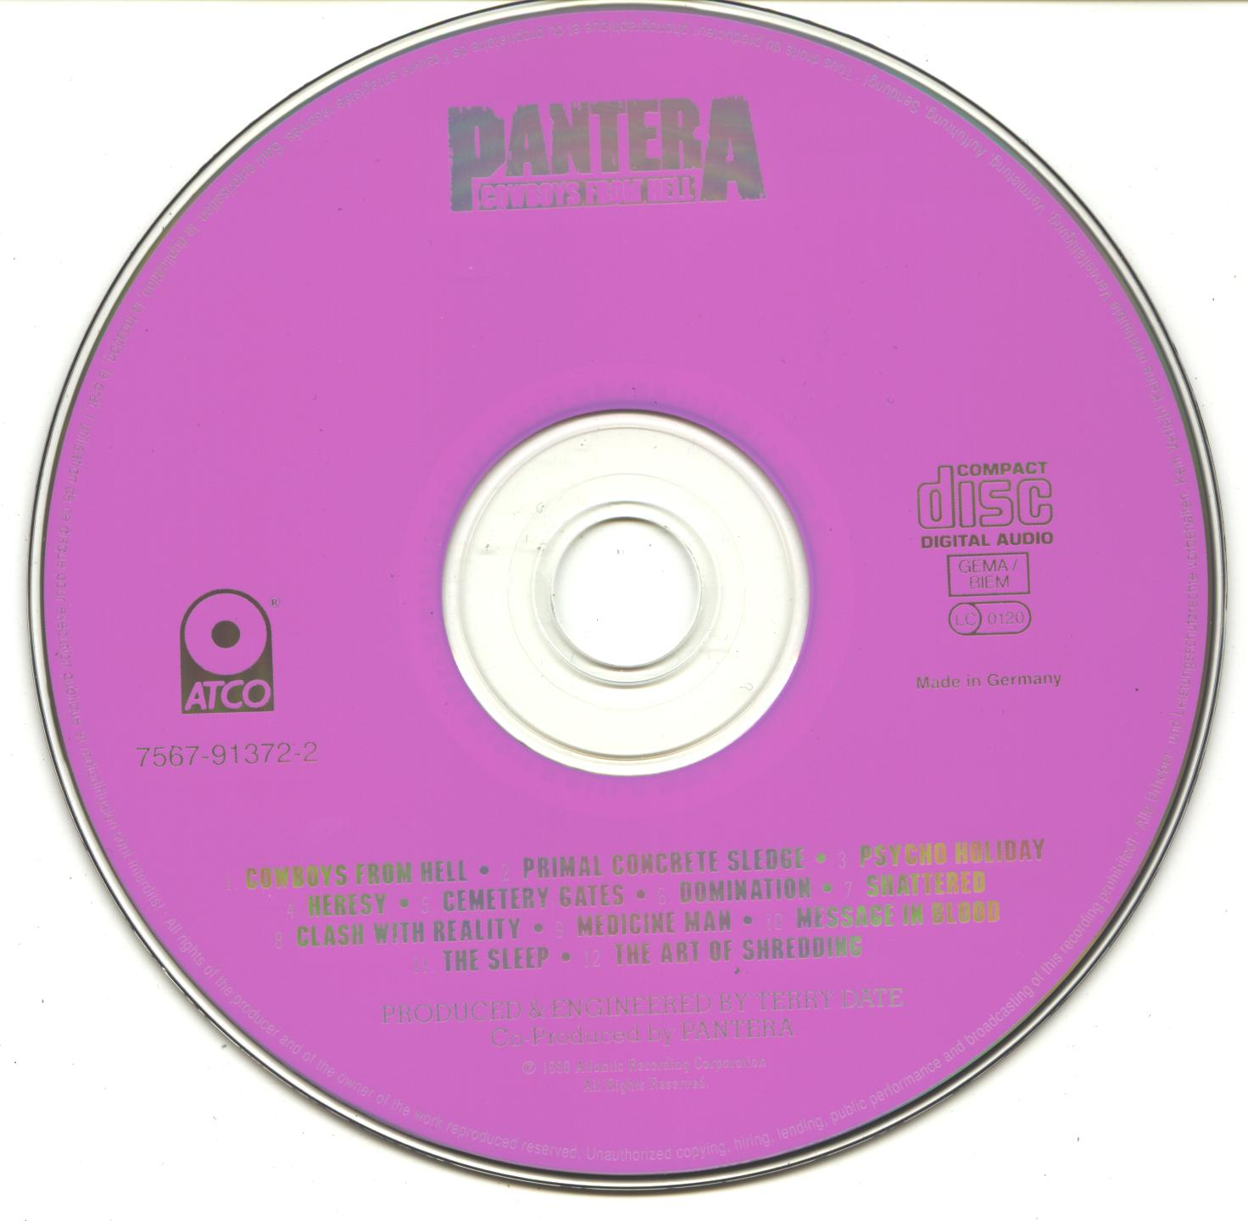To shred... its only emotion

